Assignment Structure for Programs

Your **comments** at the top of your work/flow chart or program, should contain the following:

* The Unit (example Unit 2), the Assignment number (example Assignment 1) and the Question number.
* Your Name and date you began creation/coding the question. (at the top for coding, wherever clear on flowcharts)
* Modifications you made, dated (for coding - last pieces at the top before the program begins.)
* The question or problem you were asked to solve/produce/create - at the top for coding.
* A MUST, all work, flowcharts, the Code pieces you borrowed, and ideas must be properly acknowledged (Comments in your code, footnotes on other pieces). You need to state, from where you borrowed, book/page/teacher/class notes with date/friend etc. and the link (You are encouraged to borrow “good” code and acknowledge the author/creator/writer). We borrow code all the time in the field, and we acknowledge the author. Failure to properly acknowledge what is borrowed is plagiarism and earns a zero on Communications and possibly the entire question. NOTE: You may not borrow more than 35% of your code.
* White space to make all of this easy to read
* Any notes or cautions about quirky things or test data.

**Almost every line of code should have a comment.** You can block comment. {You may use a comment for 2 or 3 rows, like “ setting up variables and constants with zero’s to eliminate infinite loops”.



**IMPORTANT - Program Naming**: Please name your Assignment programs/folders by FirstNameLastInitial, followed by U1A1Q#. The folder containing everything, does not have questions numbers. For example; Mohammed’s version of Question 4 on the assignment would be ***MohammedAU1A1Q4.***

**Note:** If your first name, last initial is not unique, you will need another initial on your last name until you are uniquely identified. (ie: Mohammed, Dan, Kevin, Adam, Sean etc.)

~~Your~~ **~~Assignment needs to be compressed~~** ~~(zipped for Windows)~~ **~~and uploaded~~** ~~to Google Classroom (not Linked) – please ask if you have never uploaded a file or compressed a group of files.~~  Remember to click the “Turn In” twice or I don’t have it for marking.

For example: The zipped file (MohammedAU1A1) Assignment 1 would contain;

~~1- A Folder MohammedAU1A1 (and all subfolders {java files, any flowcharts and text documentation.(docx or other))labeled similarly MohammedAU1A1Q1Flowchart,… MohammedAU1A1Q5~~*~~program~~*~~.java~~

The rubric applies to each question, but the weighting changes slightly for each question.

(We may make minor modifications to the rubric tomorrow in class - make sure you have the most recent version.)

One last note: Any images or photo’s must be your originals or Common License. (No Plagiarized images.)

# **Generic Rubric for Programming Assignments**

Note: Some of these items will not be marked. Obviously debugging and testing cannot be marked until taught – When in doubt ASK!

|  |  |  |  |  |  |
| --- | --- | --- | --- | --- | --- |
| Achievement Category/Skill/  Practice (level 3, expectation | Level 4  (80-100%) | Level 3  (70-79%) | Level 2  (60-60%) | Level 1  (50-59%) | Below Level 1 |
| **Communication** | | | | | |
| **User Interface:**  ✦Spelling and grammar perfect  ✦ Clear and concise language | ✦Excellent  ✦Excellent | Perfect spelling & grammar for user  d | ✦Fair  ✦Clear but too concise seems abrupt | ✦Poor  ✦Uncertain or confusing | Incomplete |
| **Readability**:  ✦code is well organized and very easy to follow. (spelling and grammar ignored as long as readable and understandable on internal documentation)  ✦ Follows standard programming practices (IE: block of code well documented) or documented inline or above if comment too long.  ✦ Writers and authors acknowledged properly | Code unique and explained  efficiency Matches your program | -clear & concise  -white space  -useful comment  Neat – straight lines – arrows – y/n t/f (intent rather than code) | ✦ **some**          ✦**some** | ✦ **limited**          ✦**few** | Incomplete |
| **Application** | | | | | |
| **Use of programming structures:**  (will vary depending upon Assignment) - flowcharts/IPO/pseudo-code/Proj. Mgmt/Ghant charts etc., | >7=76 % match with final code | <= 75% or less matched perfectly | ✦Fair | ✦Poor | Incomplete |
| **Debugging**  ✦either contains statements showing effective debugging/ error avoidance or obviously done through using tools; code error free for purposes of the assignment | ‘Dumb user’ proofed  -better beyond scope or expectations | Obvious defaults work – dumb user – expected stuff handled | ✦Somewhat effective | ✦Limited effectiveness |  |
| **Test Data:**  ✦ Thoroughly tested and test data submitted | (covered off weird stuff too?) | Everything works as expected | ✦Developssome data to test | ✦Develops little or no data to test |  |
| **Solution to Problem:**  ✦ produces correct output for all or almost all data cases – (matches output sample given on problems where a standard output is expected.) | Value added for user (nice – thank you etc.) | Correct output | ✦Fair | ✦Poor |  |
| **Thinking & Inquiry** | | | | | |
| **Problem Definition:** ✦clearly states and addresses all components of the problem | Value added for user (nice – thank you etc.) | Correct output | ✦Fair | ✦Poor |  |
| **Coding Efficiency:**  ✦code is efficient without sacrificing readability and understanding | Value added for user (nice – thank you etc.) | Correct output | ✦Pieced together | ✦Poor design or limited understanding evident |  |
| **Appropriate use of Structures:**  ✦ (names of variables, classes, methods…) make sense and are intuitive to a programmer | Overloading with variables/parameters | Expected as listed – required. | ✦Fair | ✦Poor |  |
| **Knowledge** | | | | | |
| **Correct usage of:**  ✦ procedures  ✦ terminology  ✦ concepts (appropriate to assignment and current lessons) | Overloading with variables/parameters | Expected as listed – required. | ✦Considerable | ✦Some or Fair |  |
| **Marks:** | | | | | |
|  | Communication: | Application: | Think. & Inq.: | Knowledge: |  |
| **Comments:** |  |  |  |  |  |
| **Marks Split:** |  |  |  |  |  |
| **Overall Mark:** |  | | | | |

Assignment # 1 - out of 80.

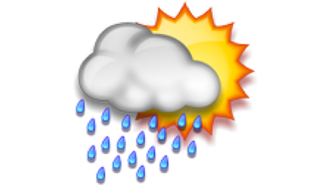1) (Basic – Java) Make a flowchart then write a program to input a txt file (or xml file) of weather data. The data contains a number of header lines you may not want to import. Create a nice GUI display for your user allowing them to query the precipitation, wind etc. data by province/city/town and receive summary or detailed data as requested. (The files have been placed in today Google Classroom.)

Application **/4** Communication **/5**

Thinking & Inquiry **/3** Knowledge  **/3**

**[ Total marks /15 ]**

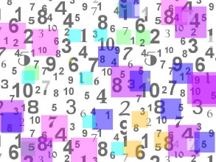

2) (Swift) Make a flowchart, then write a program that takes an array of unknown size containing ints and doubles, positive and negative numbers. Your task is to sort the array into three separate arrays of positive ints, positive doubles and all negatives. The original numbers are entered by the user, then displayed, then split and displayed again with appropriate titles for each.

Application **/4** Communication **/5**

Thinking & Inquiry **/3** Knowledge  **/3**

**[ Total marks /15 ]**

3) (Android App) Create a very basic Tip Calculator App. You will need to display;

* the original amount
* 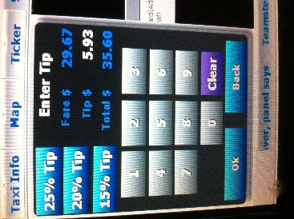an option for a 15% tip
* an option for a user, custom%
* a display of the total based on the tip.
* each keyboard number, in standard form
* a back, undo, decimal, return etc. (likely a button, but does not have to be.)

your choice of GUI output style (easiest is either buttons and display boxes or a grid)

4) (Swift App) Create a Navigation item with four directional arrows. When the user chooses up, you should show a picture of something up high. When the user chooses down, you should show something in that direction. The left arrow will signify something back and the right arrow, whatever you want. Make sure the user has a nice exit for your app.

Application **/4** Communication **/5**

Thinking & Inquiry **/3** Knowledge  **/3**

**[ Total marks /15 ]**



5) Impress me with your recursion or I/O or sorting and searching. You should include, GUI, Images, Listeners, Buttons an other GUI classes.

Wite a program that uses two of the above listed elements.

Have fun with this one!

Application (includes flowchart) **/5** Communication (includes flowchart) **/5**

Thinking & Inquiry **/5** Knowledge  **/5**

**[ Total marks /20]**